**7 PDA: Software Development**

**Level 8 - Student Evidence Checklist**

|  |  |  |
| --- | --- | --- |
| **Full name** | **Scott Murray** | **Key:** A & D - Analysis and Design Unit  I & T - Implementation and Testing Unit  P - Project Unit |
| **Cohort** | **G3** |

The evidence required can be taken from your assignments, homework that you have completed on your own or by creating a specific example for the PDA.

|  |  |  |  |  |
| --- | --- | --- | --- | --- |
| **Week 2** | **Unit** | **Ref.** | **Evidence** | **Done** |
| I & T | I.T 5 | Demonstrate the use of an array in a program. Take screenshots of:   * An array in a program * A function that uses the array * The result of the function running | YES |
| I & T | I.T 6 | Demonstrate the use of a hash in a program. Take screenshots of:   * A hash in a program * A function that uses the hash * The result of the function running | YES |

REF I.T 5 – ARRAY IN PROGRAM & FUNCTION THAT USES THE ARRAY

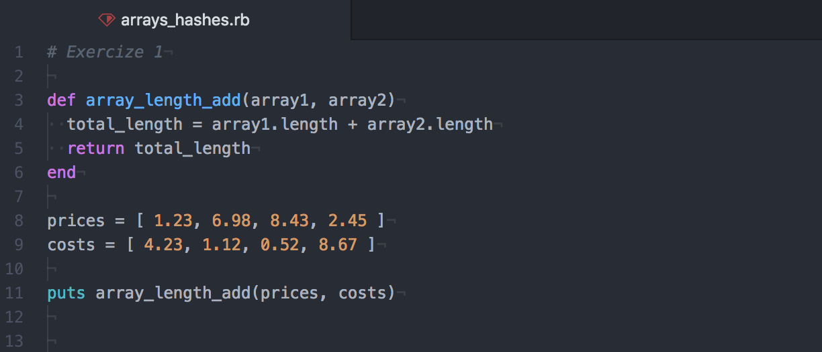

REF I.T 5 – RESULT OF FUNCTION RUNNING WITH GIVEN ARRAYS

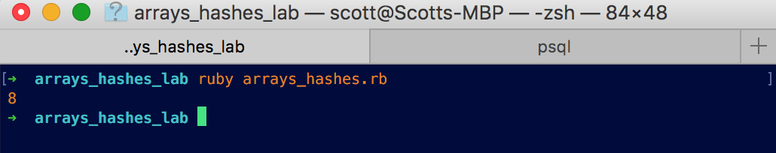

REF I.T 6 – HASH IN A PROGRAM & FUNCTION USING HASH

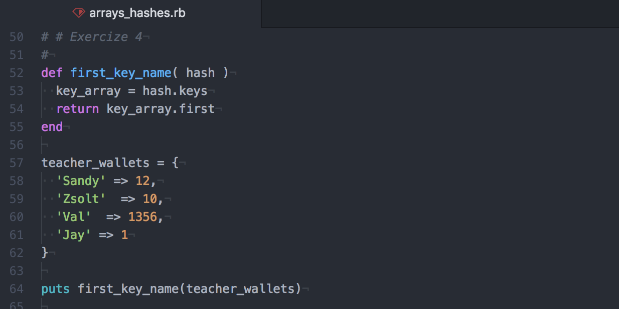

REF I.T 6 – RESULT OF FUNCTION RUNNING

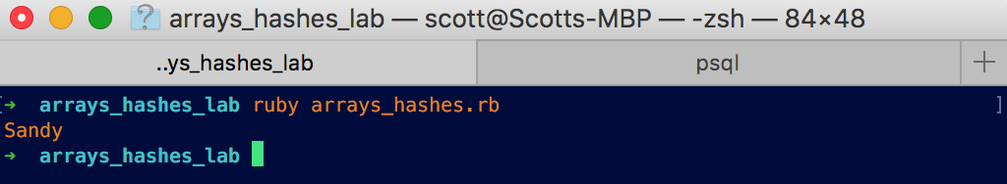

|  |  |  |  |  |
| --- | --- | --- | --- | --- |
| **Week 3** | **Unit** | **Ref.** | **Evidence** | **Done** |
| I & T | I.T 3 | Demonstrate searching data in a program. Take screenshots of:   * Function that searches data * The result of the function running | YES |
| I & T | I.T 4 | Demonstrate sorting data in a program. Take screenshots of:   * Function that sorts data * The result of the function running | YES |

|  |  |  |  |  |
| --- | --- | --- | --- | --- |
| **Week 5** | **Unit** | **Ref.** | **Evidence** | **Done** |
| A & D | A.D 1 | A Use Case Diagram |  |
| A & D | A.D 2 | A Class diagram. |  |
| A & D | A.D 3 | An Object diagram. |  |
| A & D | A.D 4 | An Activity Diagram |  |
| A & D | A.D 6 | Produce an Implementations Constraints plan detailing the following factors:   * Hardware and software platforms * Performance requirements * Persistent storage and transactions * Usability * Budgets * Time |  |
| P | P 5 | Create a user sitemap. |  |
| P | P 6 | Produce two wireframe designs. |  |
| P | P 10 | Take a screenshot of an example of pseudocode for a function. |  |
| P | P 13 | Show user input being processed according to design requirements. Take a screenshot of:   * The user inputting something into your program * The user input being saved or used in some way |  |
| P | P 14 | Show an interaction with data persistence. Take a screenshot of:   * Data being inputted into your program * Confirmation of the data being saved |  |
| P | P 15 | Show the correct output of results and feedback to user. Take a screenshot of:   * The user requesting information or an action to be performed * The user request being processed correctly and demonstrated in the program |  |
| I & T |  | Coding exercise 1: Static and Dynamic testing task A |  |

|  |  |  |  |  |
| --- | --- | --- | --- | --- |
| **Week 6** | **Unit** | **Ref.** | **Evidence** | **Done** |
| I & T | I.T 7 | Demonstrate the use of Polymorphism in a program. |  |

|  |  |  |  |  |
| --- | --- | --- | --- | --- |
| **Week 9** | **Unit** | **Ref.** | **Evidence** | **Done** |
| A & D | A.D 5 | An Inheritance Diagram |  |
| I & T | I.T 1 | Take a screenshot of an example of encapsulation in a program. |  |
| I & T | I.T 2 | Take a screenshot of the use of Inheritance in a program. Take screenshots of:   * A Class * A Class that inherits from the previous class * An Object in the inherited class * A Method that uses the information inherited from another class. |  |
| P | P 11 | Take a screenshot of one of your projects where you have worked alone and attach the Github link. |  |
| P | P 12 | Take screenshots or photos of your planning and the different stages of development to show changes. |  |

|  |  |  |  |  |
| --- | --- | --- | --- | --- |
| **Week 11** | **Unit** | **Ref.** | **Evidence** | **Done** |
| P | P 18 | Demonstrate testing in your program. Take screenshots of:   * Example of test code * The test code failing to pass * Example of the test code once errors have been corrected * The test code passing |  |

|  |  |  |  |  |
| --- | --- | --- | --- | --- |
| **Week 12** | **Unit** | **Ref.** | **Evidence** | **Done** |
| P | P 16 | Show an API being used within your program. Take a screenshot of:   * The code that uses or implements the API * The API being used by the program whilst running |  |

|  |  |  |  |  |
| --- | --- | --- | --- | --- |
| **Week 14** | **Unit** | **Ref.** | **Evidence** | **Done** |
| P | P 1 | Take a screenshot of the contributor’s page on Github from your group project to show the team you worked with. |  |
| P | P 2 | Take a screenshot of the project brief from your group project. |  |
| P | P 3 | Provide a screenshot of the planning you completed during your group project, e.g. Trello MOSCOW board. |  |
| P | P 4 | Write an acceptance criteria and test plan. |  |
| P | P 7 | Produce two system interaction diagrams (sequence and/or collaboration diagrams). |  |
| P | P 8 | Produce two object diagrams. |  |
| P | P 9 | Select two algorithms you have written (NOT the group project). Take a screenshot of each and write a short statement on why you have chosen to use those algorithms. |  |
| P | P 17 | Produce a bug tracking report |  |
| I & T |  | Coding Exercise 2: Unit and Integration testing task B |  |